Promo 01

**Unique Registration Link:**

[**https://us02web.zoom.us/w/82168151982?tk=iCFL5GyKFL_YapgpMIE6qsA-LAjbb7NVhPCiaDH5VYQ.DQkAAAATIZp_rhZjZm5fR0ROZFM5U2NuOFJ1VXJya29RAAAAAAAAAAAAAAAAAAAAAAAAAAAAAAAAAAAAAAAAAAA&uuid=WN_d2LZVB7fRcyp2VM7cFc9mg#success**](https://us02web.zoom.us/w/82168151982?tk=iCFL5GyKFL_YapgpMIE6qsA-LAjbb7NVhPCiaDH5VYQ.DQkAAAATIZp_rhZjZm5fR0ROZFM5U2NuOFJ1VXJya29RAAAAAAAAAAAAAAAAAAAAAAAAAAAAAAAAAAAAAAAAAAA&uuid=WN_d2LZVB7fRcyp2VM7cFc9mg#success)

✨ **Panel Alert!** ✨  
 📅 **October 29, 2025** | ⏰ **8:00–9:00 PM EST** 💻 **Live on Zoom + Streaming to LinkedIn & Facebook**

I’m excited to be speaking at the **Veterinary Talent Solutions Panel** —  
 **“The Workforce Crisis: Real Strategies to Recruit, Retain, and Rebuild Veterinary Teams.”**

Hosted by the **Veterinary Business Institute**, this essential panel discussion brings together industry leaders to explore actionable strategies for overcoming the current workforce challenges in veterinary medicine — and creating healthier, more resilient teams.

💡 **What You’ll Learn:** ✨ Beyond job postings: creative recruitment strategies that actually work  
 🔥 Reducing burnout through realistic scheduling and workload management  
 📈 Building career pathways that encourage professional growth  
 🤝 Retention strategies that go beyond paychecks and bonuses  
 🌿 How culture impacts recruitment and long-term loyalty

🌟 **Why Attend?** ✅ Gain practical insights from veterinary professionals who have built thriving, sustainable teams  
 💬 Learn how leadership, communication, and culture drive retention and engagement  
 🎤 Participate in a live Q&A and share your own experiences

🧡 Join us for an evening of inspiration, innovation, and connection — and walk away with real-world tools to strengthen your team and your practice.

🎟 **Complimentary Registration:** 👉 [**Reserve Your Spot Today!**](https://us02web.zoom.us/w/82168151982?tk=iCFL5GyKFL_YapgpMIE6qsA-LAjbb7NVhPCiaDH5VYQ.DQkAAAATIZp_rhZjZm5fR0ROZFM5U2NuOFJ1VXJya29RAAAAAAAAAAAAAAAAAAAAAAAAAAAAAAAAAAAAAAAAAAA&uuid=WN_d2LZVB7fRcyp2VM7cFc9mg#success)

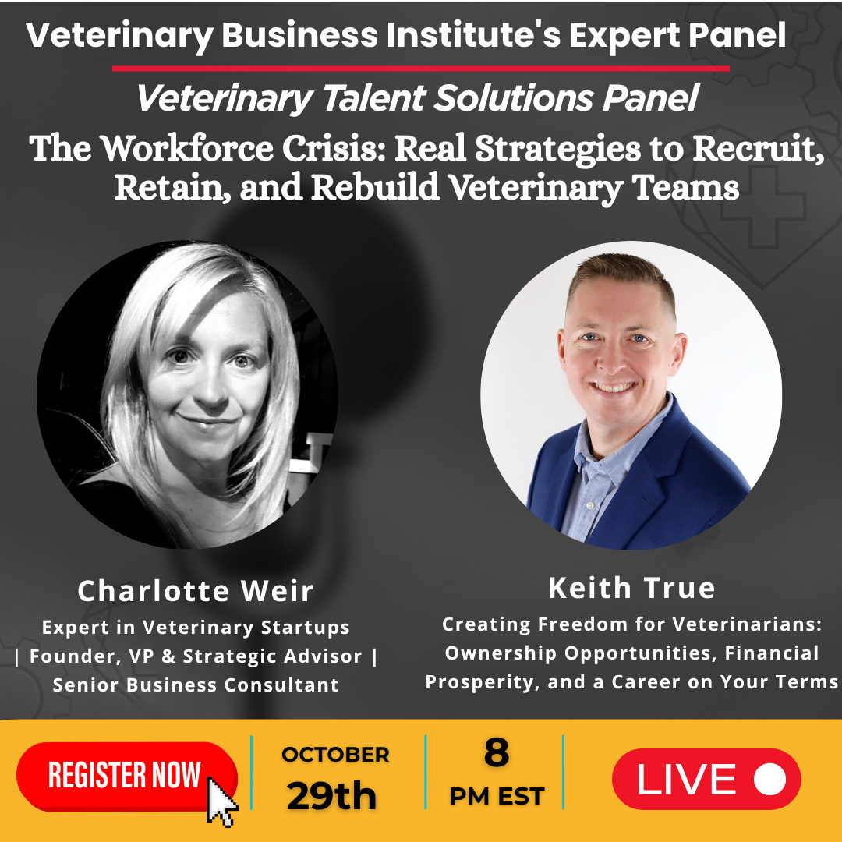

Promo 02

**Unique Registration Link:**

[**https://us02web.zoom.us/w/82168151982?tk=iCFL5GyKFL_YapgpMIE6qsA-LAjbb7NVhPCiaDH5VYQ.DQkAAAATIZp_rhZjZm5fR0ROZFM5U2NuOFJ1VXJya29RAAAAAAAAAAAAAAAAAAAAAAAAAAAAAAAAAAAAAAAAAAA&uuid=WN_d2LZVB7fRcyp2VM7cFc9mg#success**](https://us02web.zoom.us/w/82168151982?tk=iCFL5GyKFL_YapgpMIE6qsA-LAjbb7NVhPCiaDH5VYQ.DQkAAAATIZp_rhZjZm5fR0ROZFM5U2NuOFJ1VXJya29RAAAAAAAAAAAAAAAAAAAAAAAAAAAAAAAAAAAAAAAAAAA&uuid=WN_d2LZVB7fRcyp2VM7cFc9mg#success)

✨ **Panel Alert!** ✨  
 📅 **October 29, 2025** | ⏰ **8:00–9:00 PM EST** 💻 **Live on Zoom + Streaming on LinkedIn & Facebook**

I’m thrilled to be joining the **Veterinary Talent Solutions Panel** —  
 **“The Workforce Crisis: Real Strategies to Recruit, Retain, and Rebuild Veterinary Teams.”**

Hosted by the **Veterinary Business Institute**, this dynamic discussion brings together leading experts to share practical, real-world solutions for addressing the veterinary workforce crisis and building stronger, more sustainable teams.

💡 **What You’ll Learn:** ✨ Creative recruitment strategies that go beyond traditional job postings  
 🔥 Proven approaches to reduce burnout through smarter scheduling and workload management  
 📈 How to build clear career pathways that encourage long-term growth and development  
 🤝 Effective retention strategies that extend beyond paychecks and bonuses  
 🌿 The powerful role culture plays in recruitment, engagement, and loyalty

🌟 **Why Attend?** ✅ Gain actionable insights from veterinary professionals who have successfully rebuilt resilient teams  
 💬 Discover how strong leadership, communication, and culture can transform your practice  
 🎤 Participate in an interactive Q&A and share your own experiences

🧡 **Join us for an evening of insight, innovation, and inspiration — and leave with practical tools to strengthen your team and elevate your practice.**

🎟 **Complimentary Registration:**👉 [**Reserve Your Spot Today!**](https://us02web.zoom.us/w/82168151982?tk=iCFL5GyKFL_YapgpMIE6qsA-LAjbb7NVhPCiaDH5VYQ.DQkAAAATIZp_rhZjZm5fR0ROZFM5U2NuOFJ1VXJya29RAAAAAAAAAAAAAAAAAAAAAAAAAAAAAAAAAAAAAAAAAAA&uuid=WN_d2LZVB7fRcyp2VM7cFc9mg#success)

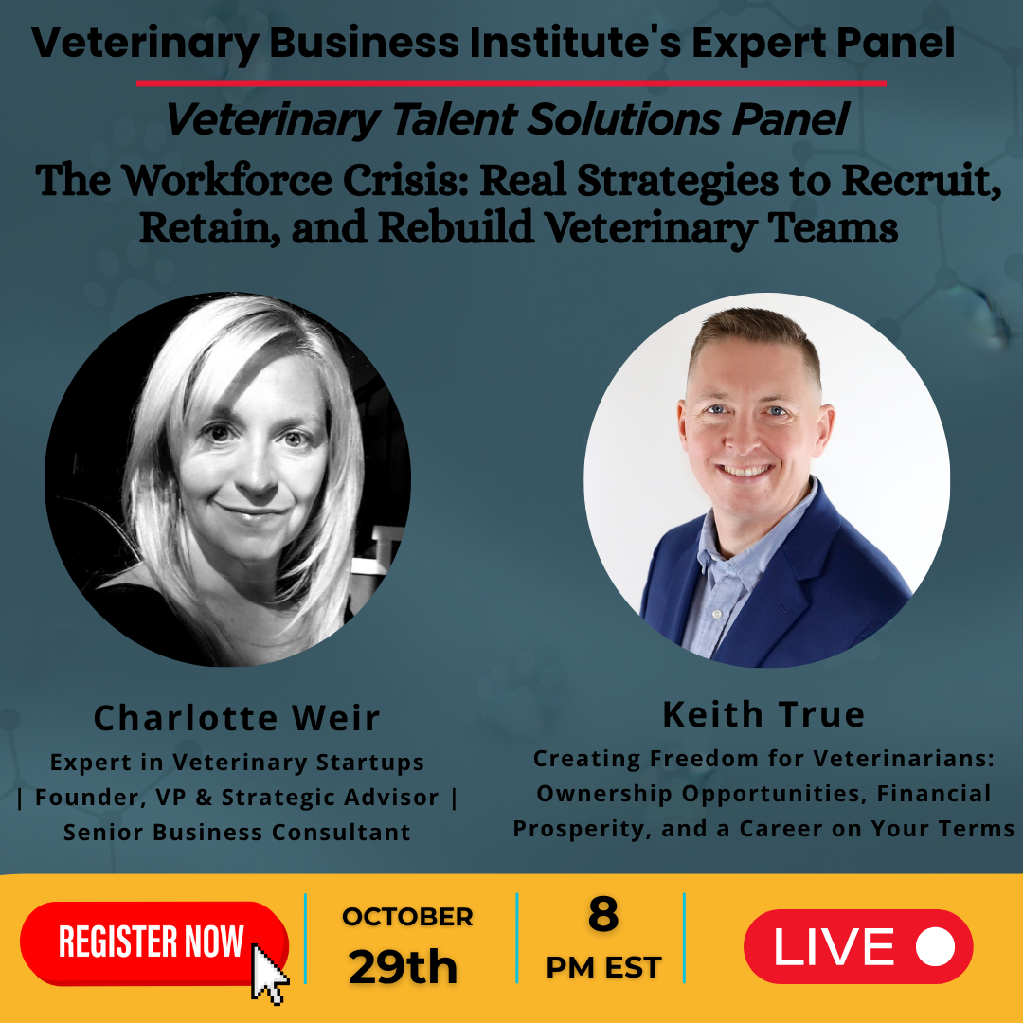

Promo 03

**Unique Registration Link:**

[**https://us02web.zoom.us/w/82168151982?tk=iCFL5GyKFL_YapgpMIE6qsA-LAjbb7NVhPCiaDH5VYQ.DQkAAAATIZp_rhZjZm5fR0ROZFM5U2NuOFJ1VXJya29RAAAAAAAAAAAAAAAAAAAAAAAAAAAAAAAAAAAAAAAAAAA&uuid=WN_d2LZVB7fRcyp2VM7cFc9mg#success**](https://us02web.zoom.us/w/82168151982?tk=iCFL5GyKFL_YapgpMIE6qsA-LAjbb7NVhPCiaDH5VYQ.DQkAAAATIZp_rhZjZm5fR0ROZFM5U2NuOFJ1VXJya29RAAAAAAAAAAAAAAAAAAAAAAAAAAAAAAAAAAAAAAAAAAA&uuid=WN_d2LZVB7fRcyp2VM7cFc9mg#success)

✨ **Join Me for a Vital Discussion on Veterinary Workforce Solutions** ✨  
  
 The veterinary profession is facing one of its greatest challenges — a workforce in crisis. How can we recruit, retain, and rebuild stronger, more resilient teams?

I’m honored to be a panelist for the upcoming event:  
 **“The Workforce Crisis: Real Strategies to Recruit, Retain, and Rebuild Veterinary Teams.”**

Hosted by the **Veterinary Business Institute**, this discussion goes beyond theory to share *real, actionable solutions* that are transforming veterinary practices across the country.

Join us as we explore proven strategies for:  
 🐾 Attracting top talent with creative and effective recruitment approaches  
 🐾 Reducing burnout through balanced scheduling and workload management  
 🐾 Building meaningful career pathways for long-term team growth  
 🐾 Strengthening retention through culture, communication, and connection  
 🐾 Creating workplaces where veterinary professionals truly thrive

📅 **Date:** Wednesday, October 29, 2025  
 ⏰ **Time:** 8:00 PM – 9:00 PM EST  
 💻 **Location:** Live on Zoom + Streaming to LinkedIn & Facebook

🎟️ **Registration is complimentary — reserve your spot today:** 👉 [**Reserve Your Spot Today!**](https://us02web.zoom.us/w/82168151982?tk=iCFL5GyKFL_YapgpMIE6qsA-LAjbb7NVhPCiaDH5VYQ.DQkAAAATIZp_rhZjZm5fR0ROZFM5U2NuOFJ1VXJya29RAAAAAAAAAAAAAAAAAAAAAAAAAAAAAAAAAAAAAAAAAAA&uuid=WN_d2LZVB7fRcyp2VM7cFc9mg#success)

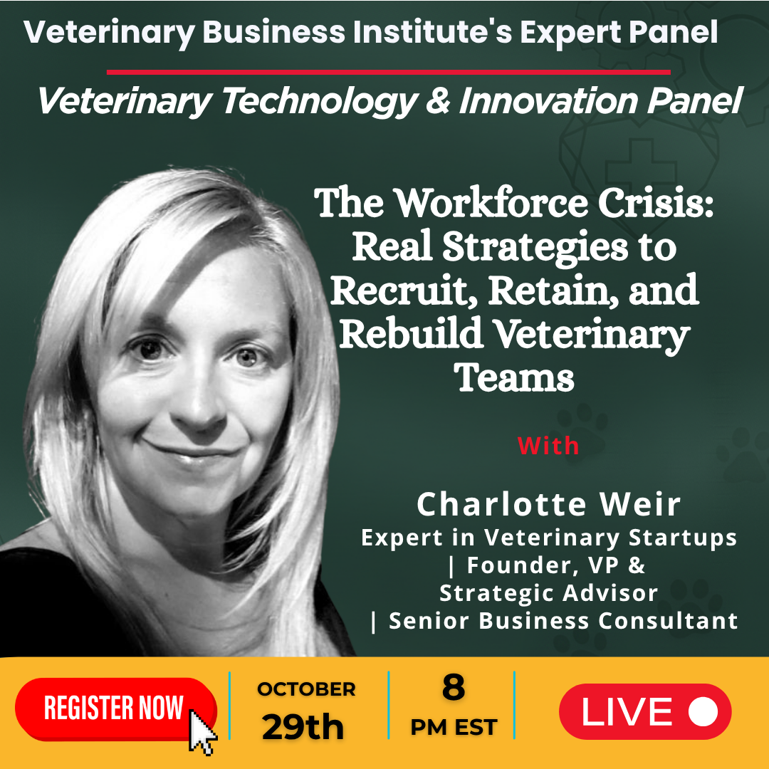

Promo 04

**Unique Registration Link:**

[**https://us02web.zoom.us/w/82168151982?tk=iCFL5GyKFL_YapgpMIE6qsA-LAjbb7NVhPCiaDH5VYQ.DQkAAAATIZp_rhZjZm5fR0ROZFM5U2NuOFJ1VXJya29RAAAAAAAAAAAAAAAAAAAAAAAAAAAAAAAAAAAAAAAAAAA&uuid=WN_d2LZVB7fRcyp2VM7cFc9mg#success**](https://us02web.zoom.us/w/82168151982?tk=iCFL5GyKFL_YapgpMIE6qsA-LAjbb7NVhPCiaDH5VYQ.DQkAAAATIZp_rhZjZm5fR0ROZFM5U2NuOFJ1VXJya29RAAAAAAAAAAAAAAAAAAAAAAAAAAAAAAAAAAAAAAAAAAA&uuid=WN_d2LZVB7fRcyp2VM7cFc9mg#success)

✨ **One More Day to Go! Join Me for This Critical Conversation Tomorrow!** ✨

The countdown is on! Tomorrow, I’m honored to be a panelist for the **Veterinary Talent Solutions Panel**:  
 **“The Workforce Crisis: Real Strategies to Recruit, Retain, and Rebuild Veterinary Teams.”**

As veterinary practices everywhere face mounting workforce challenges, this discussion will offer *real, actionable strategies* to help teams rebuild stronger, healthier, and more connected than ever.

There’s still time to join us as we explore key topics, including:  
  
 🐾 Creative recruitment strategies that actually work — beyond traditional job postings  
 🐾 Reducing burnout through balanced scheduling and realistic workload management  
 🐾 Building career pathways that promote professional growth and satisfaction  
 🐾 Retention strategies that go beyond paychecks and bonuses  
 🐾 How workplace culture shapes recruitment and long-term loyalty

📅 **Date:** Tomorrow, Wednesday, October 29, 2025  
 ⏰ **Time:** 8:00 PM – 9:00 PM EST  
 💻 **Location:** Live on Zoom + Streaming to LinkedIn & Facebook

This is a must-attend session for anyone passionate about strengthening veterinary teams and creating thriving, sustainable practices.

🎟️ **Registration is complimentary. Don’t miss out — secure your spot for tomorrow’s session below:** 👉 [**Reserve Your Spot Today!**](https://us02web.zoom.us/w/82168151982?tk=iCFL5GyKFL_YapgpMIE6qsA-LAjbb7NVhPCiaDH5VYQ.DQkAAAATIZp_rhZjZm5fR0ROZFM5U2NuOFJ1VXJya29RAAAAAAAAAAAAAAAAAAAAAAAAAAAAAAAAAAAAAAAAAAA&uuid=WN_d2LZVB7fRcyp2VM7cFc9mg#success)

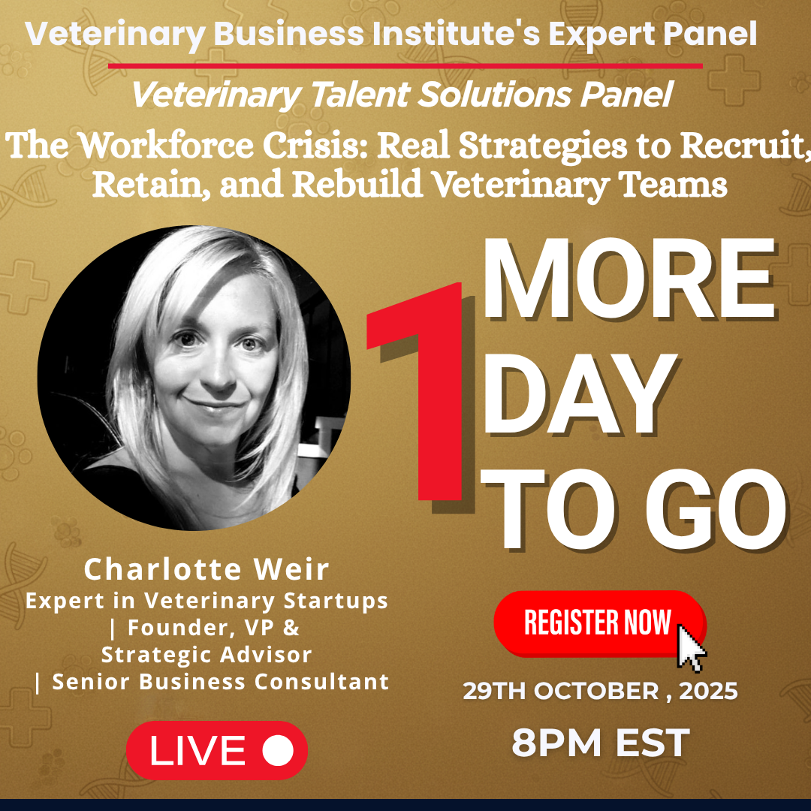

Promo 05

**Unique Registration Link:**

[**https://us02web.zoom.us/w/82168151982?tk=iCFL5GyKFL_YapgpMIE6qsA-LAjbb7NVhPCiaDH5VYQ.DQkAAAATIZp_rhZjZm5fR0ROZFM5U2NuOFJ1VXJya29RAAAAAAAAAAAAAAAAAAAAAAAAAAAAAAAAAAAAAAAAAAA&uuid=WN_d2LZVB7fRcyp2VM7cFc9mg#success**](https://us02web.zoom.us/w/82168151982?tk=iCFL5GyKFL_YapgpMIE6qsA-LAjbb7NVhPCiaDH5VYQ.DQkAAAATIZp_rhZjZm5fR0ROZFM5U2NuOFJ1VXJya29RAAAAAAAAAAAAAAAAAAAAAAAAAAAAAAAAAAAAAAAAAAA&uuid=WN_d2LZVB7fRcyp2VM7cFc9mg#success)

✨ **It’s Happening Tonight! Final Call to Register!** ✨

📅 **When:** Tonight, October 29, 2025 | ⏰ **8:00 PM – 9:00 PM EST** 💻 **Where:** Live on Zoom + Streaming to LinkedIn & Facebook

The day has arrived! I’m thrilled to be joining the **Veterinary Talent Solutions Panel** tonight for our discussion —  
 **“The Workforce Crisis: Real Strategies to Recruit, Retain, and Rebuild Veterinary Teams.”**

This is your *final chance* to join us live for a powerful, solutions-focused conversation on how we can strengthen, support, and rebuild our veterinary teams for the future.

Here’s what we’ll be diving into:  
 🐾 Creative recruitment strategies that actually work — beyond job postings  
 🔥 Reducing burnout through realistic scheduling and workload management  
 📈 Building career pathways that foster professional growth  
 🤝 Retention strategies that go deeper than paychecks and perks  
 🌿 How culture drives engagement, loyalty, and long-term success

If you’re passionate about creating thriving, sustainable veterinary practices, this session is not to be missed.

🎟️ **Registration is complimentary and gives you immediate access — don’t wait!** 👉 [**Reserve Your Spot Today!**](https://us02web.zoom.us/w/82168151982?tk=iCFL5GyKFL_YapgpMIE6qsA-LAjbb7NVhPCiaDH5VYQ.DQkAAAATIZp_rhZjZm5fR0ROZFM5U2NuOFJ1VXJya29RAAAAAAAAAAAAAAAAAAAAAAAAAAAAAAAAAAAAAAAAAAA&uuid=WN_d2LZVB7fRcyp2VM7cFc9mg#success)

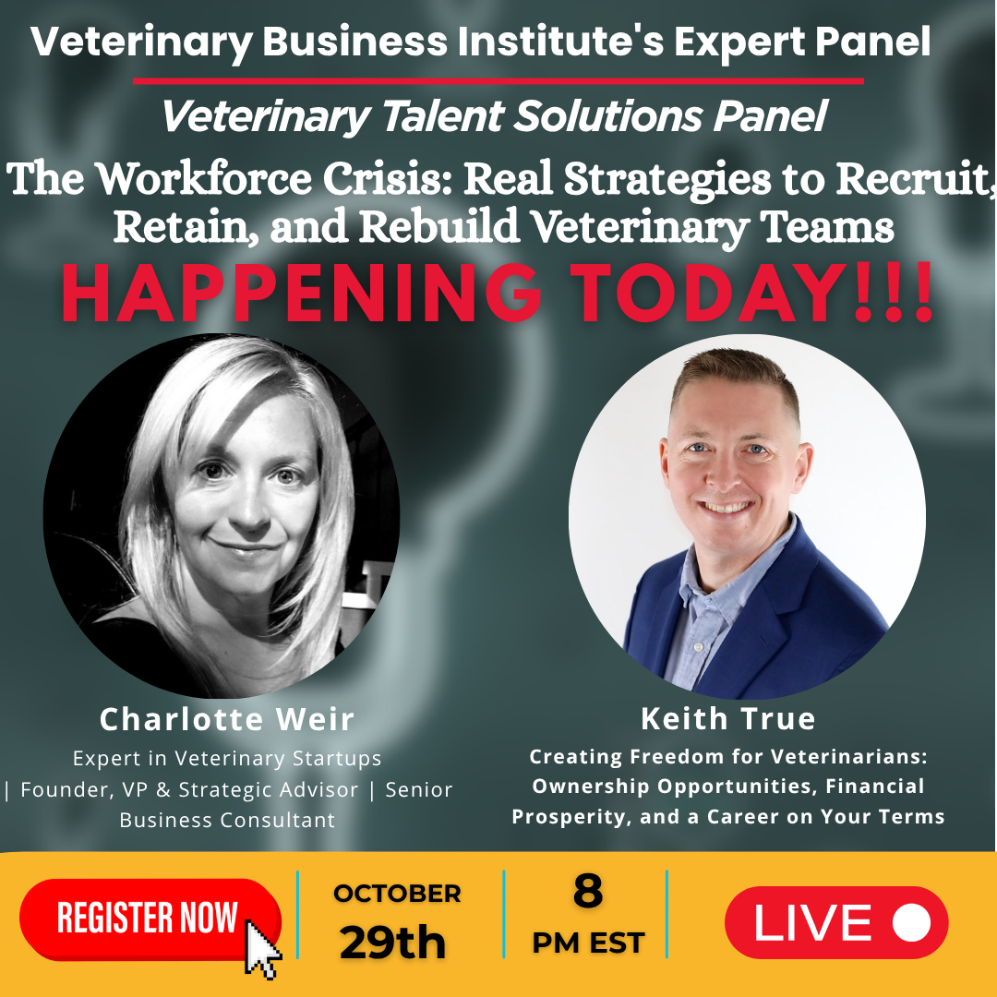

Email Promotion

**Subject:** Join Me Tomorrow for the Veterinary Talent Solutions Panel 🐾

Hi there,

✨ **Just one day to go!** ✨

I’m excited to invite you to join me for the **Veterinary Talent Solutions Panel** —  
 **“The Workforce Crisis: Real Strategies to Recruit, Retain, and Rebuild Veterinary Teams.”**

📅 **Date:** October 29, 2025  
 ⏰ **Time:** 8:00–9:00 PM EST  
 💻 **Where:** Live on Zoom (also streaming to LinkedIn & Facebook)

Hosted by the **Veterinary Business Institute**, this insightful panel will bring together veterinary leaders to share practical, real-world solutions for today’s workforce challenges — helping you strengthen, support, and sustain your team for the long term.

We’ll be covering:  
  
 🐾 Creative recruitment strategies that actually work — beyond job postings  
 🔥 Reducing burnout through realistic scheduling and workload management  
 📈 Building clear career pathways to encourage professional growth  
 🤝 Retention strategies that go beyond paychecks and bonuses  
 🌿 How culture shapes recruitment, engagement, and loyalty

🎟 **Complimentary Registration:** 👉 [**Reserve Your Spot Today!**](https://us02web.zoom.us/w/82168151982?tk=iCFL5GyKFL_YapgpMIE6qsA-LAjbb7NVhPCiaDH5VYQ.DQkAAAATIZp_rhZjZm5fR0ROZFM5U2NuOFJ1VXJya29RAAAAAAAAAAAAAAAAAAAAAAAAAAAAAAAAAAAAAAAAAAA&uuid=WN_d2LZVB7fRcyp2VM7cFc9mg#success)

I’d love for you to join us and share your perspective as we explore how to build stronger, healthier, and more connected veterinary teams.